Key considerations when choosing Regions –

* Compliance
* Proximity
* Feature availability
* Pricing

Advantages of Deploying multi-Region and multi-AZ resources

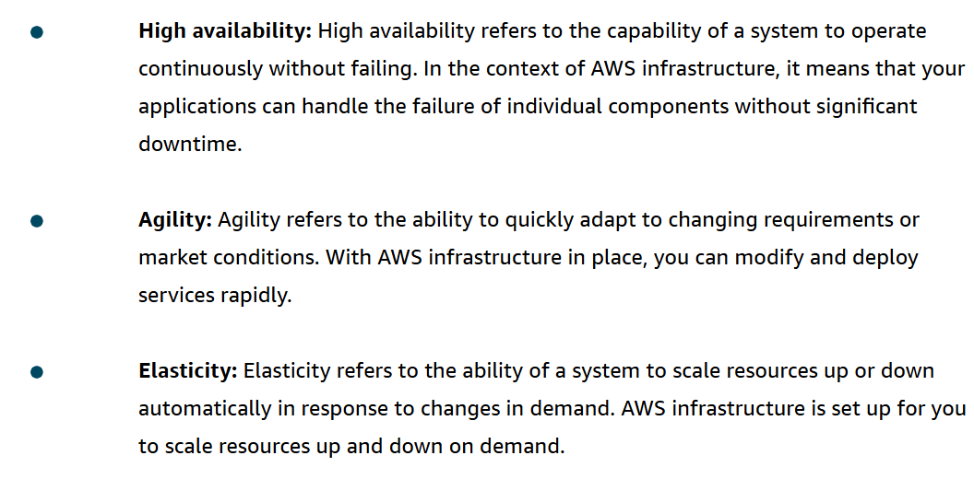

Edge locations - AWS has a global edge network that provides quicker content access to users outside of standard Regions.

